**Practical No. 19 Write a program to demonstrate the use of PreparedStatement and ResultSet interface.**

**XIII. Exercise**

1. **Develop JDBC program to retrieve data using ResultSet**

import java.sql.*;

public class pract19_ex1

{private static final String url = "jdbc:mysql://localhost:3306/msbte";

private static final String username = "root";

private static final String pasword = "ksp1303@@##ok";

public static void main(String[] args)

{try{

Class.forName("com.mysql.cj.jdbc.Driver");

Connection connection = DriverManager.getConnection(url, username, pasword) ;

Statement statement = connection.createStatement();

String query = "Select * from msbte.student";

ResultSet resultSet = statement.executeQuery(query);

// Printing the table

while(resultSet.next())

{int r = resultSet.getInt("RollNo");

String n = resultSet.getString("Name");

Float p = resultSet.getFloat("Percent");

System.out.print("Roll No:" + r + " Name:" + n +" Percent: " +p);

System.out.println("\n");

}}

catch(Exception e)

{

e.printStackTrace();

}

}}

**Output:**

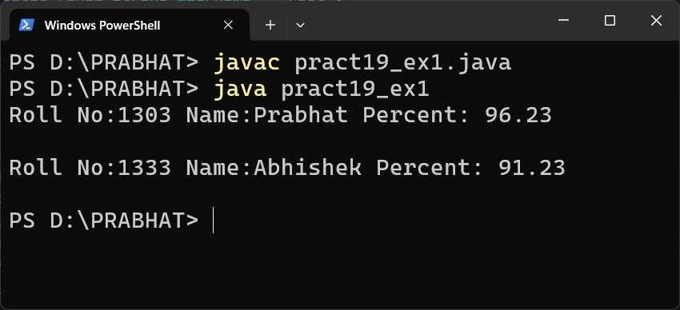

1. **Develop a program to update a record in database table.**

import java.sql.*;

public class pract19_ex2

{private static final String url = "jdbc:mysql://localhost:3306/msbte";

    private static final String username = "root";

    private static final String pasword = "ksp1303@@##ok";

    public static void main(String[] args)

    {try

    {Class.forName("com.mysql.cj.jdbc.Driver");

        Connection c =  DriverManager.getConnection(url, username, pasword);

        Statement s = c.createStatement();

        String q = String.format("UPDATE msbte.student SET Percent = %f WHERE RollNo = %d" , 91.23 , 1333);

s.executeUpdate(q);

System.out.println("Connection successful");

}catch(Exception e)

    { e.printStackTrace();

    }}}

**Before Update:**

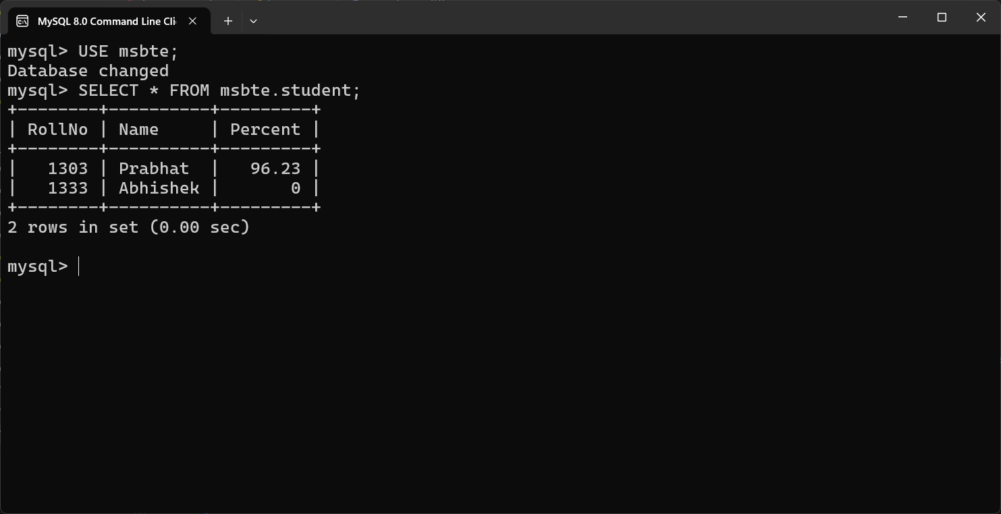

**After Update:**

